RLE(char level-poem)

Members: Karima Hussein, Marwa Yasser ,Nancy Ahmed

Introduction: applying Run-Length encoding/decoding on text (poem)

Flowchart:

Compression :

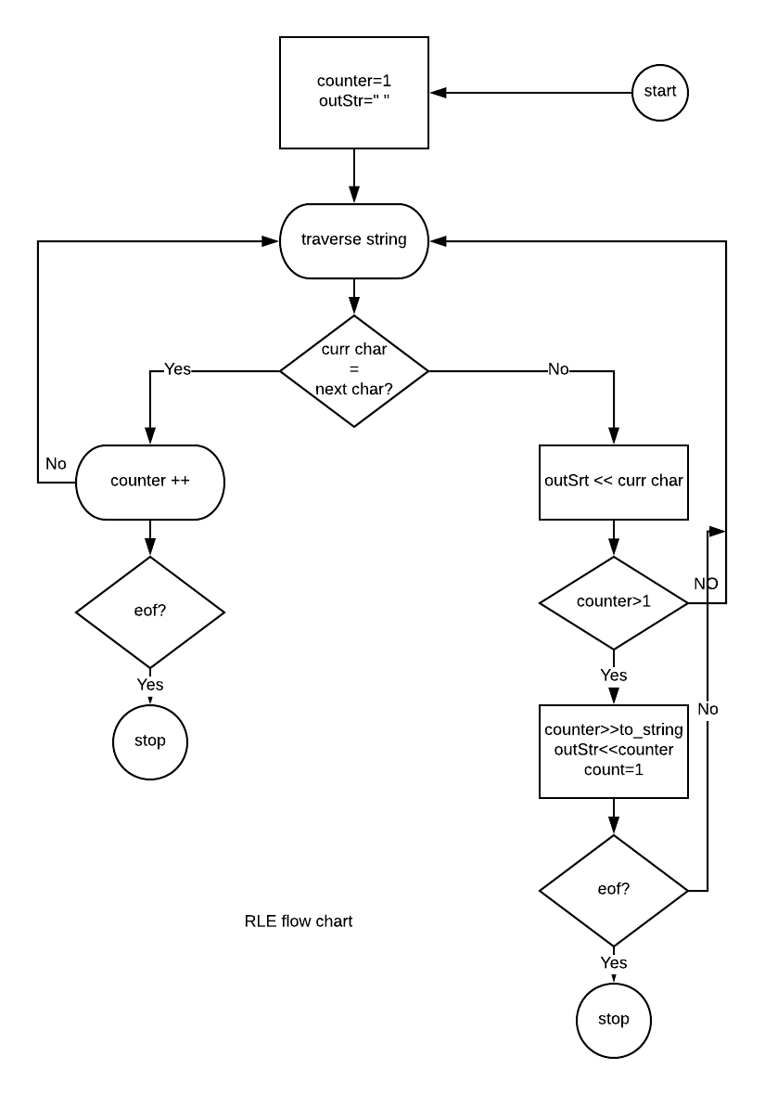

Decompression:

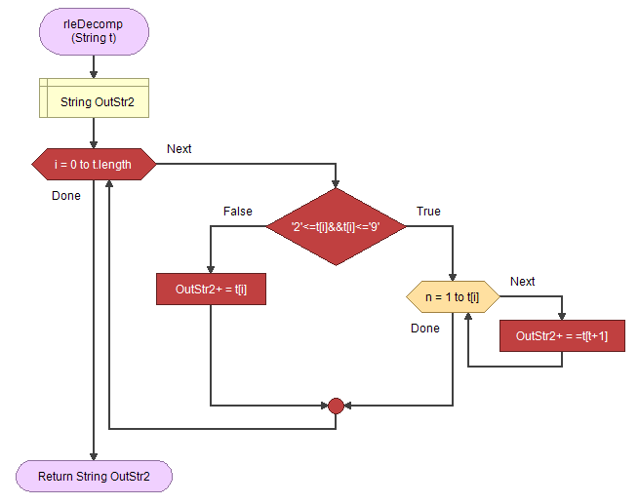

Output sample:

Compression:  
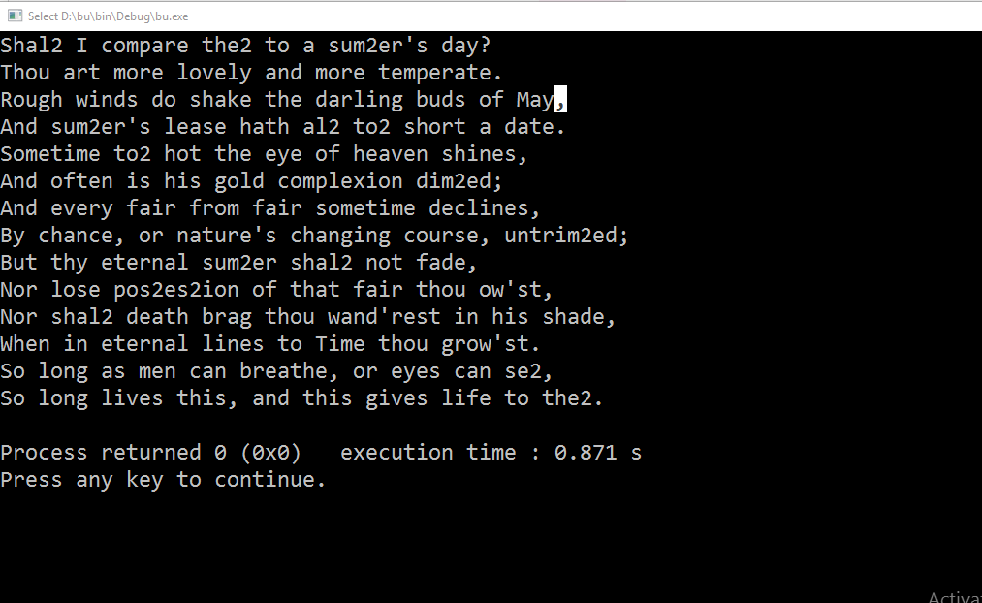

Decompression:

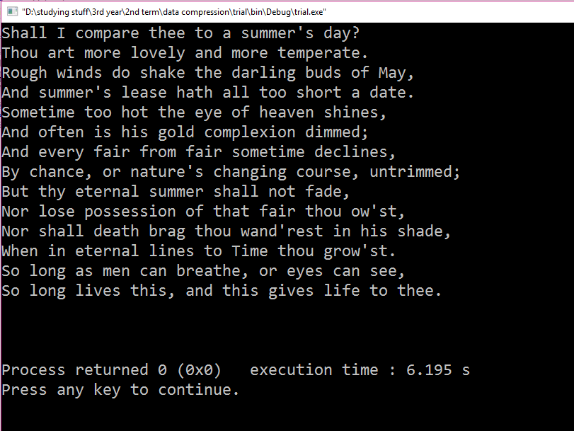

Conclusion:  
the algorithm is not suitable for a poem as the sequential repeat of a specific letter in a word rarely exceed 3 times . In worst case scenario all the letters are different which can lead to doubling the size instead of compressing it (here in our case we handled that case by compressing only if the times of repeat is more than 1 .